## APPENDIX 1

**HELPING HANDS**

END TERM REPORT

***by***

**ERATHUVATHIKAL LIKITHA KRISHNA**

**NIKHILESH KUMAR VERMA**

**MEDISHETTI SUMANTHVARMA**

(SECTION: K19KK)

(ROLL NO(S): 61,62,63)





**Department of Intelligent Systems**

**School of Computer Science Engineering Lovely Professional University, Jalandhar**

APRIL-2020

## APPENDIX 2

**Student Declaration**

This is to declare that this report has been written by me/us. No part of the report is copied from other sources. All information included from other sources have been duly acknowledged. I/We aver that if any part of the report is found to be copied, I/we are shall take full responsibility for it.

ERATHUVATHIKAL LIKITHA KRISHNA

REGISTRATION NO:11904187

ROLL NO:61

NIKHILESH KUMAR VERMA

REGISTRATION NO:11904133

ROLL NO:62

MEDISHETTI SUMANTHVARMA

REGISTRATION NO:11904199

ROLL NO:63

Punjab……………………………………………………………………………………………………

April 9, 2020

**APPENDIX 3**

**TABLE OF CONTENTS**

1. Aim of the project
2. Features
3. Special elements
4. Advantages
5. Disadvantages
6. Work Division
7. Screenshots of the code
8. Bonafide Certificate

**COMPLAINT MANAGEMENT SYSTEM-**

**AIM:** To design a website where people can register their complaints about anything from anywhere.

This website will help the public to write their grievances and get solutions for their problems. The main objective of this project is to solve public problems and make their lives happier. This website will give provision to enter the public inconvenience in their normal life, the website will be viewed by anybody and considered for the further actions by the authorities.

This website is developed on HTML, CSS and JavaScript.

**FEATURES**:

* **HOME PAGE** : This page contains the basic information about the website.
* **ABOUT**  : It contains the information of website, what is the website about, how to use it.
* **GALLERY**  : The pictures uploaded by the public will be shown in this page and also photos of the work process done by authorities.
* **CONTACT**  : This page will help the public to contact higher authorities.

**Special elements:**

1. **Color-overlay**
2. **Inline block list**
3. **Hover**
4. **Box-shadow**
5. **Transition-delay**
6. **Overflow**
7. **Animation**
8. **Cursor**

**Advantages:**

* The system automatically collects the information, images to report to related authority.
* Users don’t have to visit any office to report their grievances.
* Thus, it saves human efforts and resources and yes, it solves issues faced by people.
* People can even call authorities and resolve their problems by contacting through webpage.

**Disadvantages:**

* Users must have a reliable internet connection.
* Not a disadvantage but a caution that if people report fake complaints then some serious action will be taken against them.

**Work Division:**

* Pre-submission report and CSS code by ERATHUVATHIKAL LIKITHA KRISHNA.
* CSS code and JavaScript coding by NIKHILESH KUMAR VERMA.
* HTML code and final report by MEDISHETTI SUMANTH VARMA.

**SCREENSHOTS OF WEBSITE :**

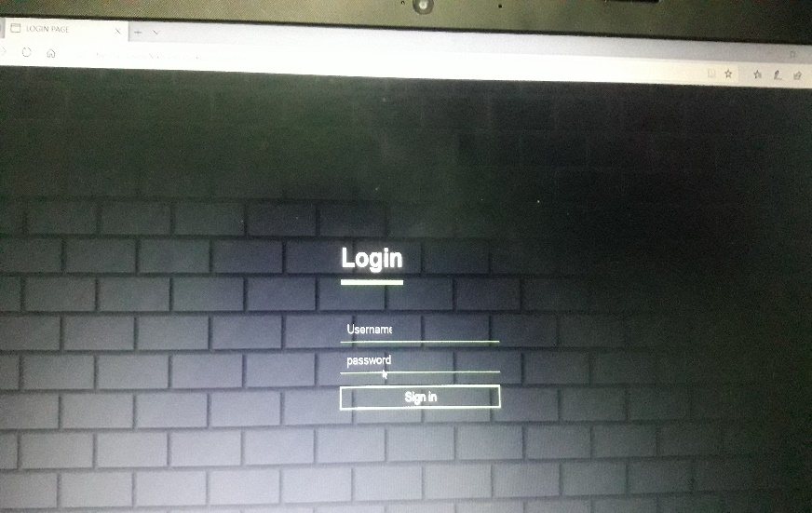

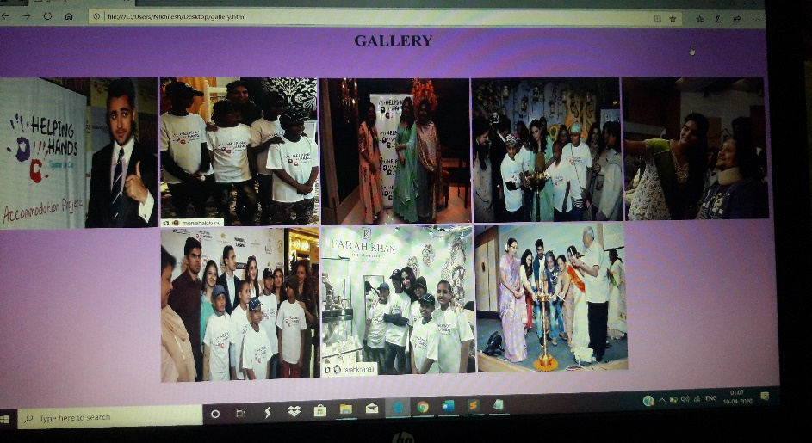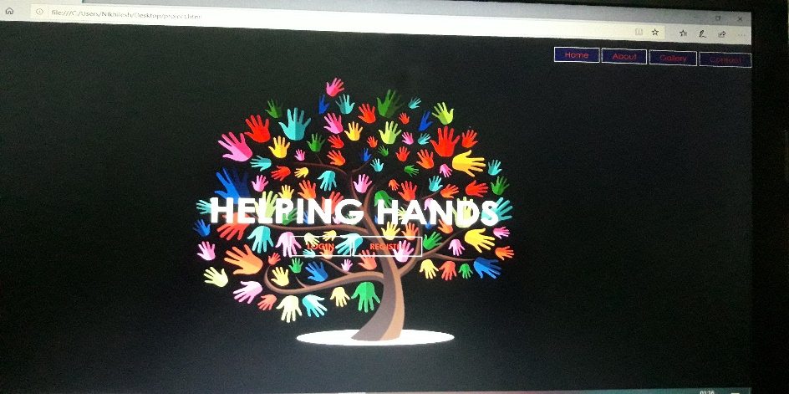

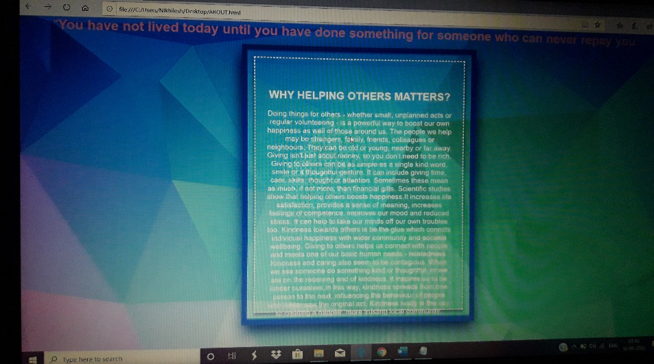

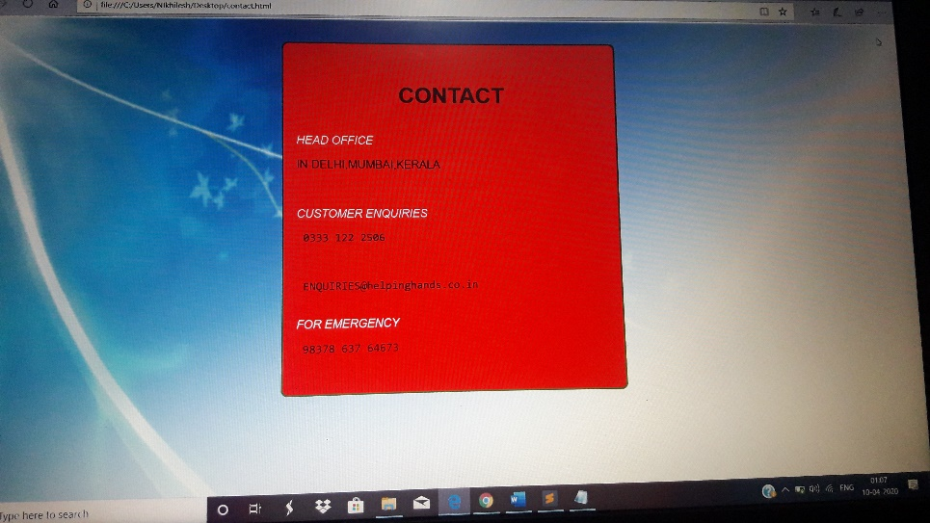

APPENDIX 4

BONAFIDE CERTIFICATE

Certified that this project report “HELPING HANDS” is the bonafide work of “ERATHUVATHIKAL LIKITHA KRISHNA, NIKHILESH KUMAR VERMA,” who carried out

the project work under my supervision.

### <<Signature of the Supervisor>>

<<Name of supervisor>>

<<Academic Designation>>

<<ID of Supervisor>>

<<Department of Supervisor>>